Project title: Contact manager
Team leader: krithika J
Krithikajayakanthan@gmail.com
Team members:
1.Kavya sri K
ksri11006@gmail.com
2.keerthika S
Keerthikasathivel187@gmail.com
3.Magarasi E K
magarasisakkiyappa@gmail.com
TEAM ID:SWTID-2026-6481
github LINK: https://github.com/krithikajayakanthan-rgb/Contact-manager.git
1.PROJECT OVERVIEW:
- Purpose:
The Contact Manager project is designed to store, manage, and organize contact information efficiently. The main goal of this project is to allow users to add, update, delete, and view contact details such as name, phone number, email, and address.
This system helps users maintain their contacts in a structured and easily accessible manner.
- Features:
- Add new contact details.
- View all saved contacts.
- Update existing contact information.
- Delete contacts when they are no longer needed.
- Search contacts quickly using name or phone number.
- Secure data handling through backend APIs.
2.Architecture:
- Component Structure:
- The backend application follows a modular structure where different components handle specific tasks.
- Routes handle incoming requests from the client.
- Controllers process the requests and send responses.
- Models define the structure of the contact data in the database.
- Database stores the contact information.
- State Management:
In backend systems, state management mainly involves handling data requests and responses between the server and database. The application processes HTTP requests and manages data through APIs.
- Routing:
- Routing is implemented to manage different API endpoints such as:
- GET /contacts – Retrieve all contacts
- POST /contacts – Add a new contact
- PUT /contacts/:id – Update contact details
- DELETE /contacts/:id – Remove a contact
These routes help the client interact with the backend system.
3.Setup Instructions:
- Prerequisites:
Before running the project, the following software must be installed:
- Node.js
- npm (Node Package Manager)
- MongoDB (Database)
Code editor such as VS Code
- Installation:
- Clone the project repository.
- Open the project folder in the terminal.
- Install the required dependencies using npm install.
- Configure environment variables such as database connection.
- Run the server using npm start or node server.js.
4.Folder Structure
- Utilities:
- Utility files contain helper functions used throughout the project such as:
- Database connection functions
- Error handling methods
- Data validation helpers
5. Running the Application:
- To run the backend server:
- Open the project folder in the terminal.
- Run the command:
- Copy code
npm start
6. Module Documentation:
- Key Modules: Here are the key backend modules for a Contact Manager:

- Authentication Module
-User registration and login
- JWT or OAuth authentication
- Password hashing and verification
2. Contact Module
- CRUD operations for contacts
- Contact model with fields (name, email, phone, tags, etc.)
- Search and filtering functionality
3. Tag Module
- CRUD operations for tags
- Tag model with fields (name, color, etc.)
4. User Module
- User model with fields (name, email, password, etc.)
- Profile management
5. API Routes
- Routes for contacts, tags, and users
- Authentication middleware for protected route
- Reusable Modules:
Some modules and helper functions are reusable across the project. These include:
- Database connection functions
- Error handling middleware
- Input validation functions
These reusable components improve code maintainability and reduce duplication.
7. Data Management:
- Global Data Handling:
The backend manages contact data centrally in the database. All contact information is stored and retrieved using database queries. The server processes API requests and ensures that the correct data is returned to the client.
- Request Handling:
Each API request (GET, POST, PUT, DELETE) is processed by the server. The server validates the input data, performs the required database operation, and sends the appropriate response back to the client.
8. API Interface:
The backend system provides RESTful APIs that allow external applications or frontend interfaces to interact with the contact database.
- Example API operations include:
- GET /contacts – Fetch all contacts
- POST /contacts – Create a new contact
- PUT /contacts/:id – Update an existing contact
- DELETE /contacts/:id – Delete a contact
9. Backend Technologies:
The Contact Manager backend uses several technologies to ensure efficient functionality:
- Node.js – Runtime environment used to execute JavaScript on the server.
- Express.js – Framework used to build RESTful APIs and manage routing.
- MongoDB – NoSQL database used to store contact information.
- Mongoose – Library used to define schemas and interact with the MongoDB database.
10. Testing:
Testing ensures that the backend APIs work correctly and return accurate results.
The APIs can be tested using tools such as Postman by sending HTTP requests like GET, POST, PUT, and DELETE. Testing helps verify that contact data is correctly created, retrieved, updated, and deleted from the database.
11.screenshot: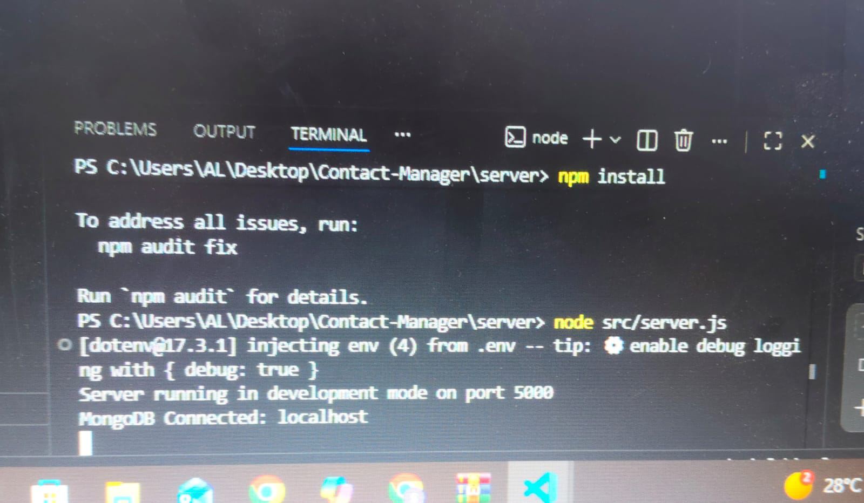
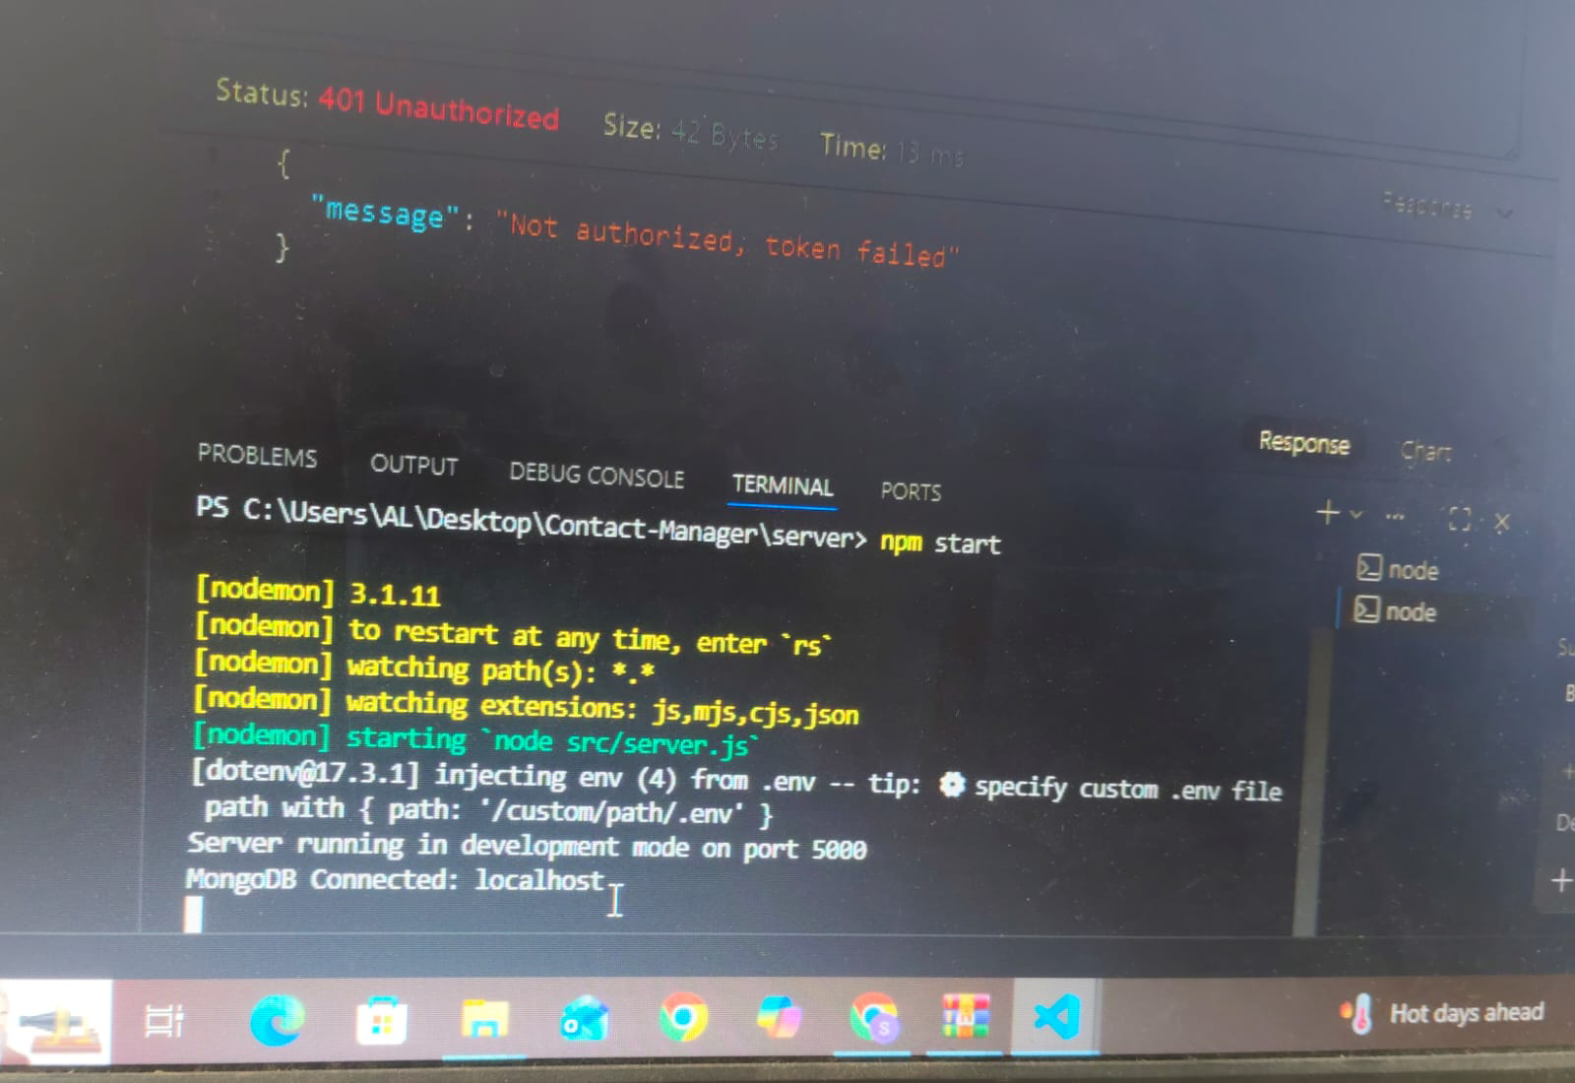

13. Demo video link:
https://drive.google.com/file/d/1MDTdUDz3MJQGjRDG7D-I0Op6I3Ec8veA/view?usp=drivesdk
14. Phase documentation link:
Phase 1:
https://drive.google.com/drive/folders/1NU47lqUD6FGME85HbzO4_UcA8zr3mefY
Phase 2:
https://drive.google.com/drive/folders/1UG8wFiZ9t-O0PDch5HC1IcYsrqNoCeIA
Phase 3:
https://drive.google.com/drive/folders/1WsU8I5fi9tqaKBeRbNgHDd8oPt3Zh7Ee
Phase 4:
https://drive.google.com/drive/folders/1sCgnhTQktG7qc_CRUyEAyAK4rIoAT6SJ

Phase 5:
https://drive.google.com/drive/folders/1pgmdUtaASEoHXU1P_7j6ah-BFwpkNk39
15.known issues:

- Limited input validation.
- No user login or authentication system.
- Designed for single user only.
- Basic error handling.
- No search or filter option for contacts.
- Limited frontend integration.
- Not suitable for large number of contacts.
16. Future enhancement:
- Add user authentication and login system.
- Implement search and filter options for contacts.
- Add profile picture upload for contacts.
- Improve data validation and error handling.
- Enable multiple user support with secure access.
- Integrate with a modern frontend interface.
- Add contact import and export feature (CSV/Excel).
- Improve database performance for large data.

